Cold Sores Flare Up due to Laser Hair Removal
If you have a history of cold sores (oral herpes simplex infection),
laser hair removal treatment can trigger a ‘flare up’
especially on upper lip, chin, lower cheeks or bikini area
This is because - exposure to the laser light and heat can activate the HSV1 virus

Symptoms –
There are 5 stages. At first, you have the telltale burning, tingling or itching sensation. Then painful, clear fluid-filled blisters will break out often grouped together in patches. After a day or two, the blisters break and the fluid oozes out forming crusting and superficial ulcers. It’s contagious at this stage. Then the ulcers will scab over forming a yellow-brown crust. And finally, the scab will flake off and healthy healing will occur, and your skin will return to normal. Usually, it will heal in 2 weeks without leaving a scar.

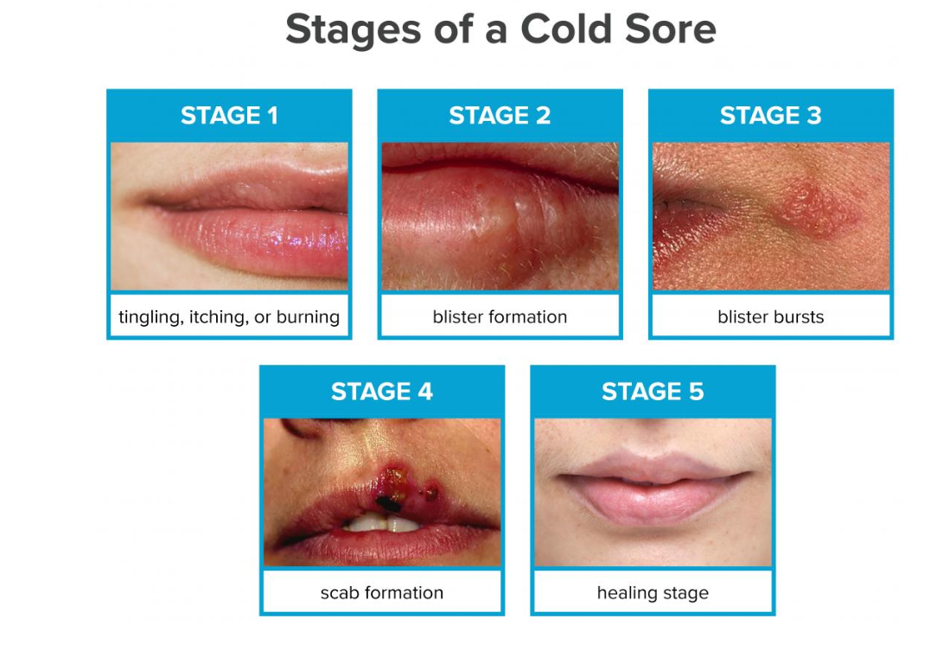

What does it look like?

Clear fluid filled blisters that are painful, red & itchy. Sometimes there is oozing and crusting scabs. And sometimes you can develop yellow pustules or pimples which is a bacterial infection on top.

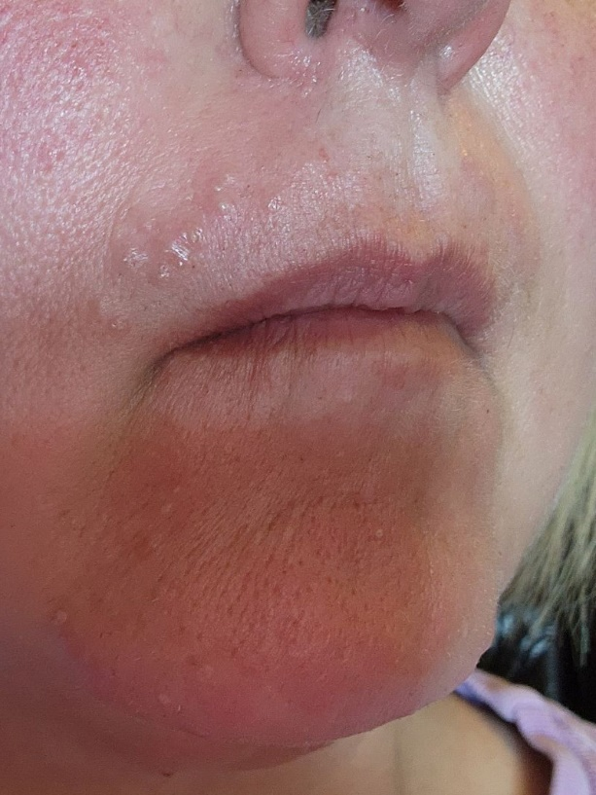
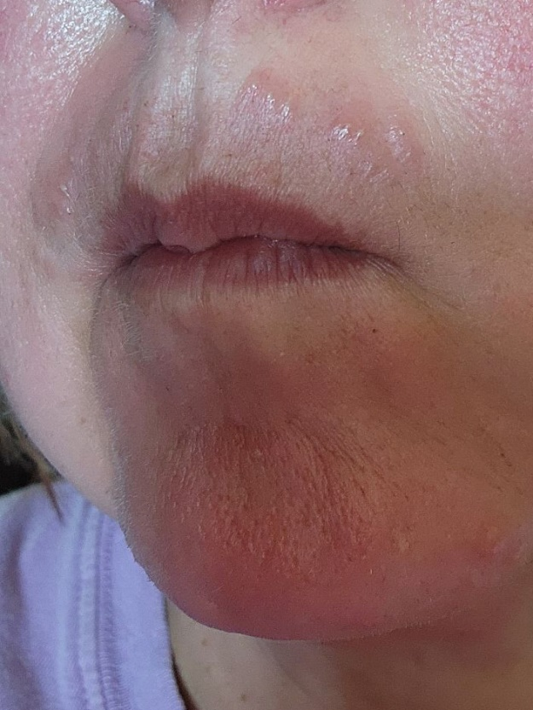

Treatment –
3 OTC creams = Abreva, Cortizone10 and Neosporin
- Use Abreva 5x a day for upto 7 days
- Use Cortizone10 and Neosporin cream both together 3x day upto 7 days

- Abreva – Is an antiviral cream that prevents the virus from multiplying. Start using it as soon as you feel the tingling and itching.

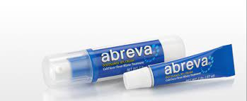

- Cortizone10 – Is an anti-inflammatory cream. It will help with pain, redness, itching and swelling.
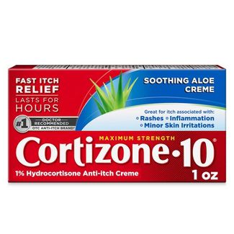

- Neosporin cream – Is an antibiotic. It will help prevent bacterial infection
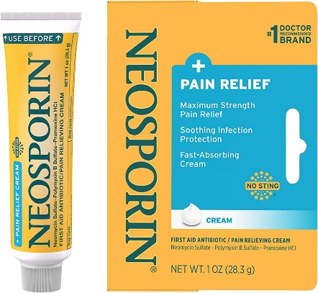

- You can also use Oral Tylenol or Ibuprofen for pain

Preventing Spread and Further Complications
Just like your smile , it’s contagious so take these steps to avoid spreading cold sores to other people.
- Avoid kissing and skin contact with people while blisters are present
- Avoid sharing personal items like towels
- Wash your hands thoroughly before touching other people, especially babies

When to call your doctor?
If blisters get bigger or spread. If you develop high fever or symptoms get worse. You might need a prescription antiviral medication eg Valtrex

How to prevent flare-ups with future Laser Hair Removal Treatments
Start Abreva & Cortizone10 cream 3x a day for 2 days prior to laser treatment and continue for 2 days afterward.
Another option is a Pre-Treatment Prescription antiviral medication eg Valtrex or Famvir.

Funny
Cold sores are not fun. Here are a couple of light-hearted ways to find humor in this uncomfortable situation to cheer you up:

- Tell people that you have a contagious smile that's spreading joy everywhere you go!
- Tell them - you posted your story online and it went viral!

Remember, laughter is the best medicine, even when it comes to laser induced cold sores.

